Debug SDRAM bank1 error:

1. External memory is enable in SDRAM_init.xml file (added on)
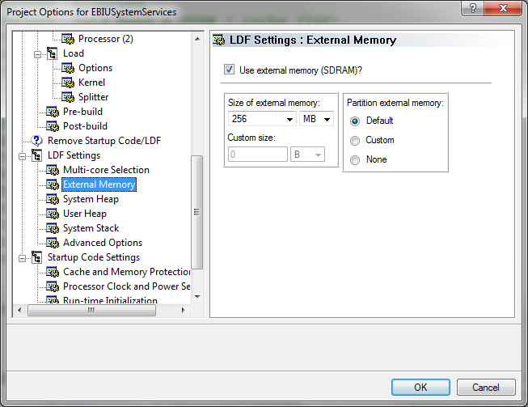

2. Using SDRAM bank1 – buffer1 is in this area - bank1 is able to write into it.
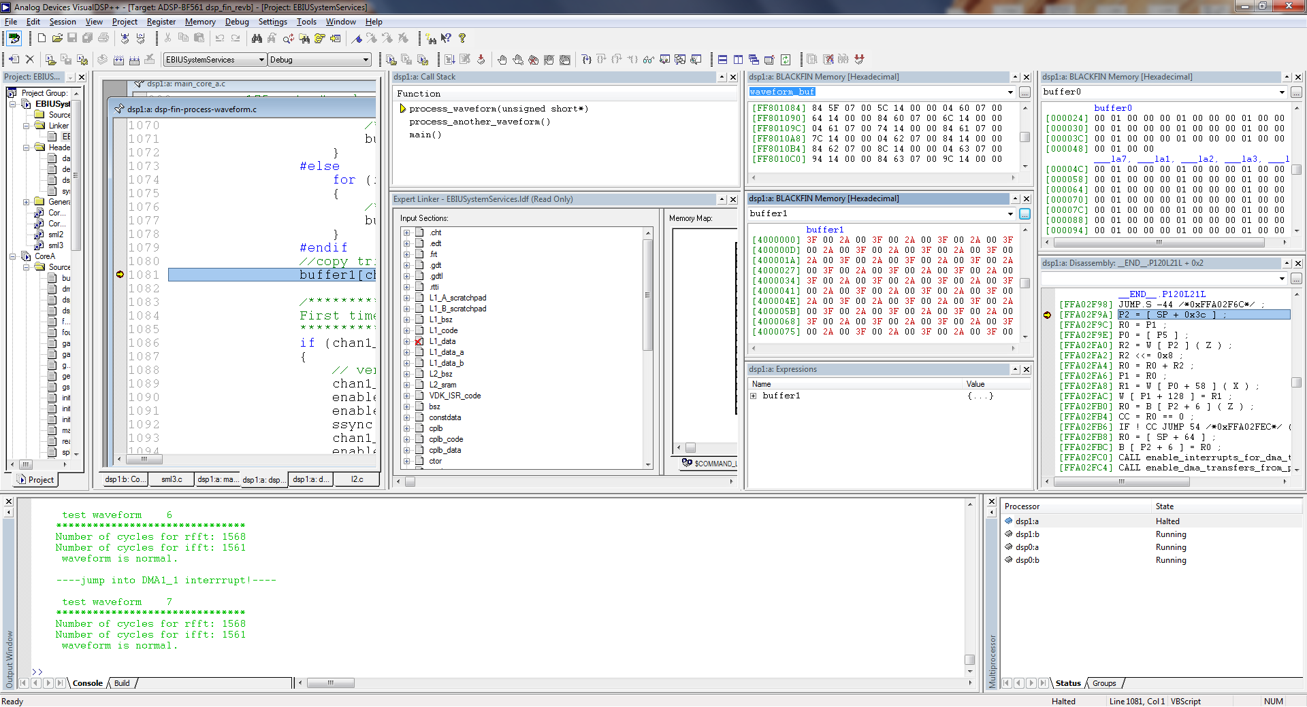
Error: write first 16 bits value, the rest of memory will be filled in same value.
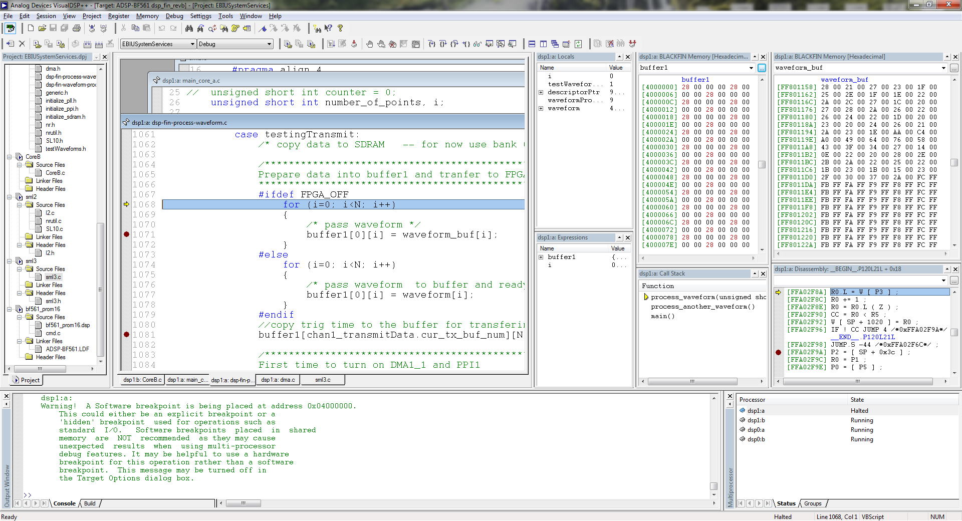

3. Compare using sdram bank0, the value is always good and does not change to random data.
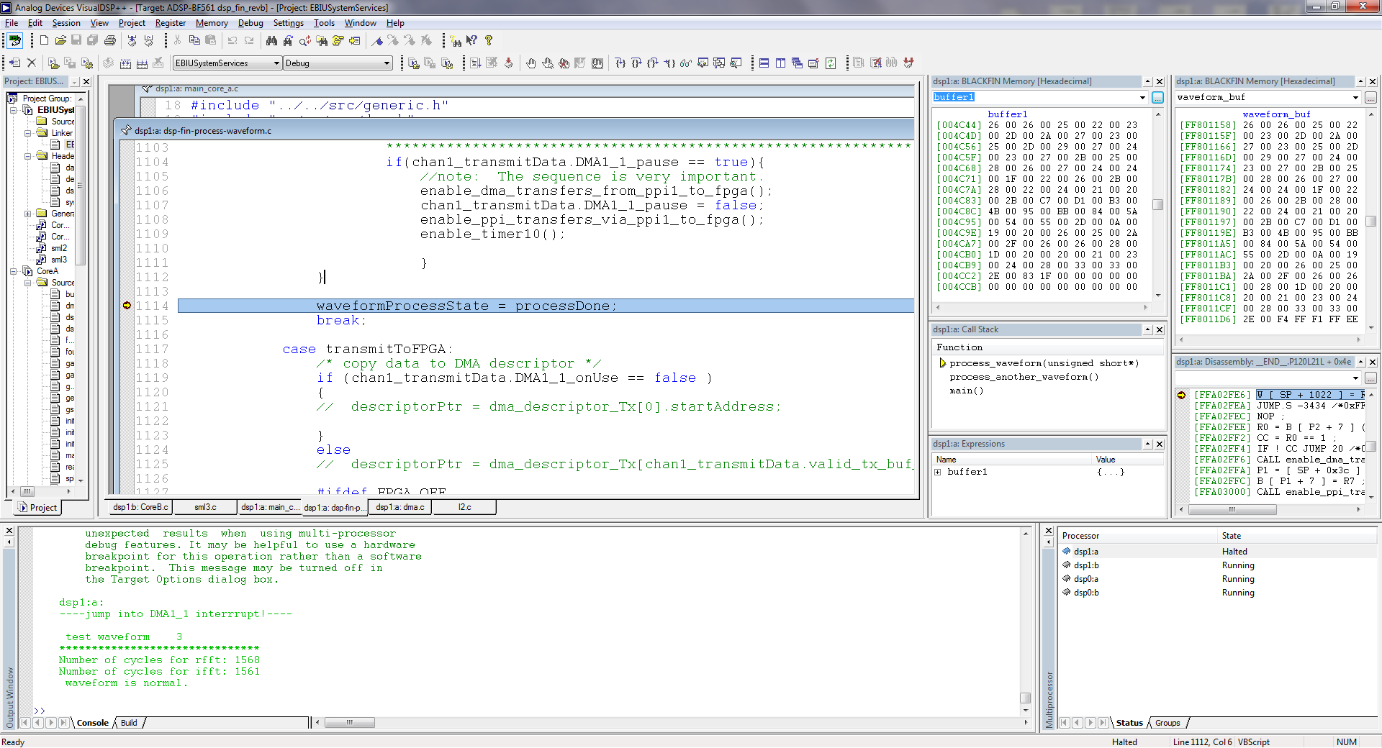

I switched to old version which does not modified anyfiles before doing sdram, and it works very stable. Please see following screen shots:
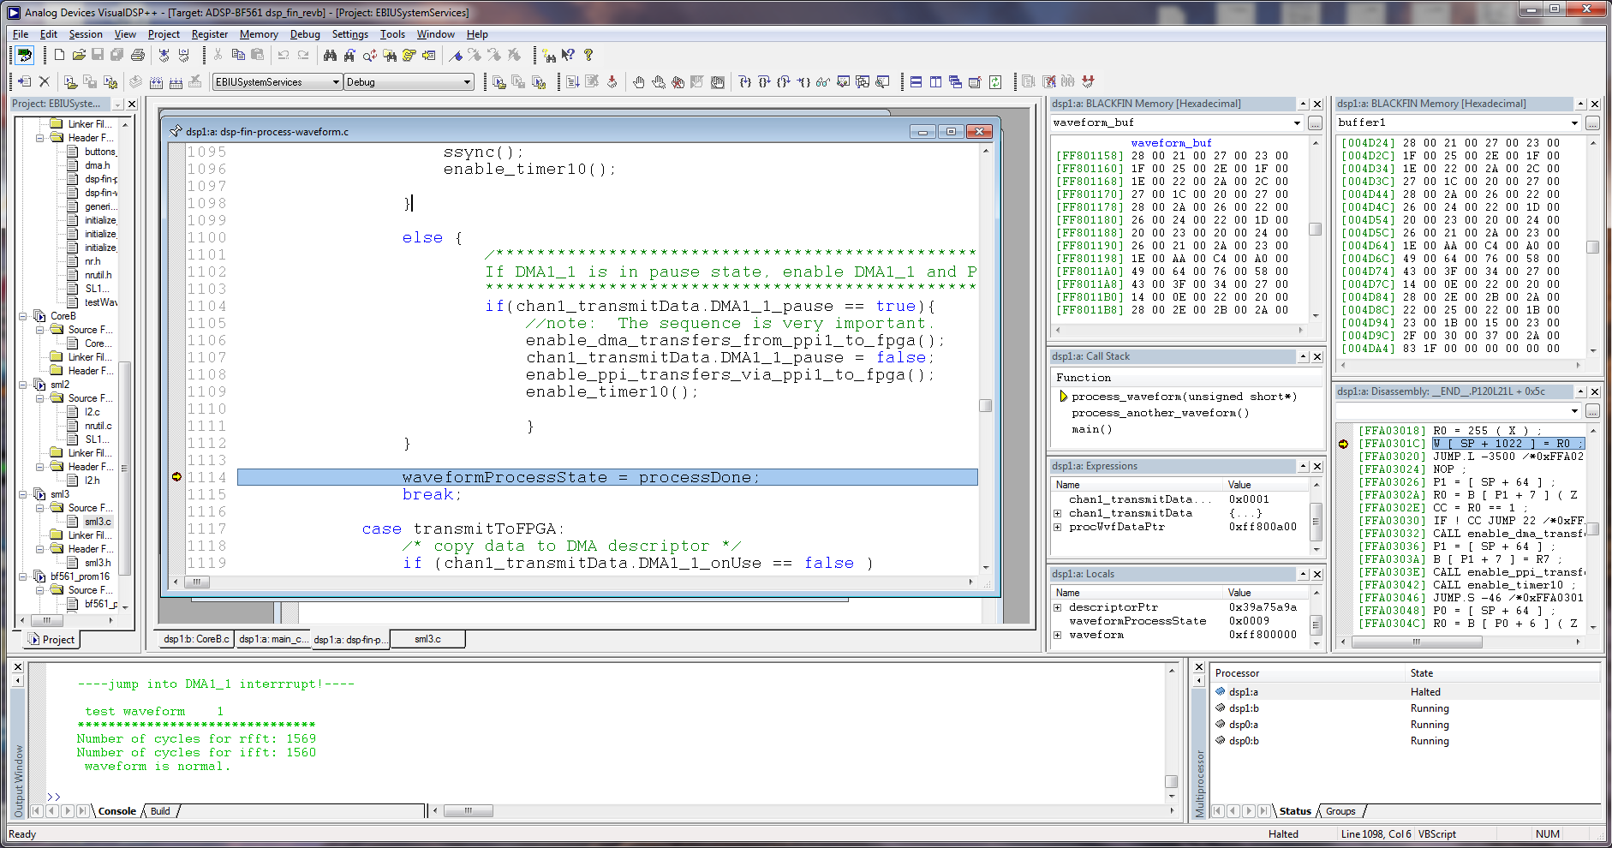

Problem might be:
- I might mess up the slm3.c file.

Write error indication:
When write a high byte to sdram, all sdram buffer is filled with its high byte with the same value. See screen shot:
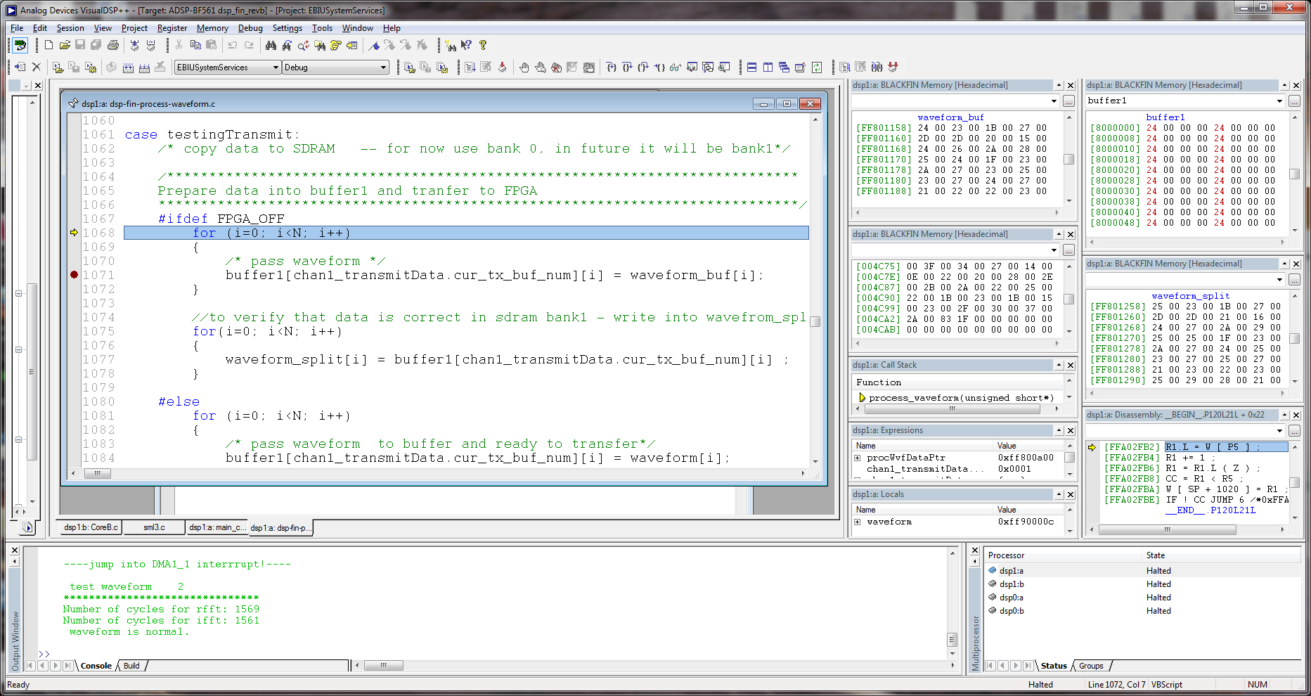
High byte 24 00

